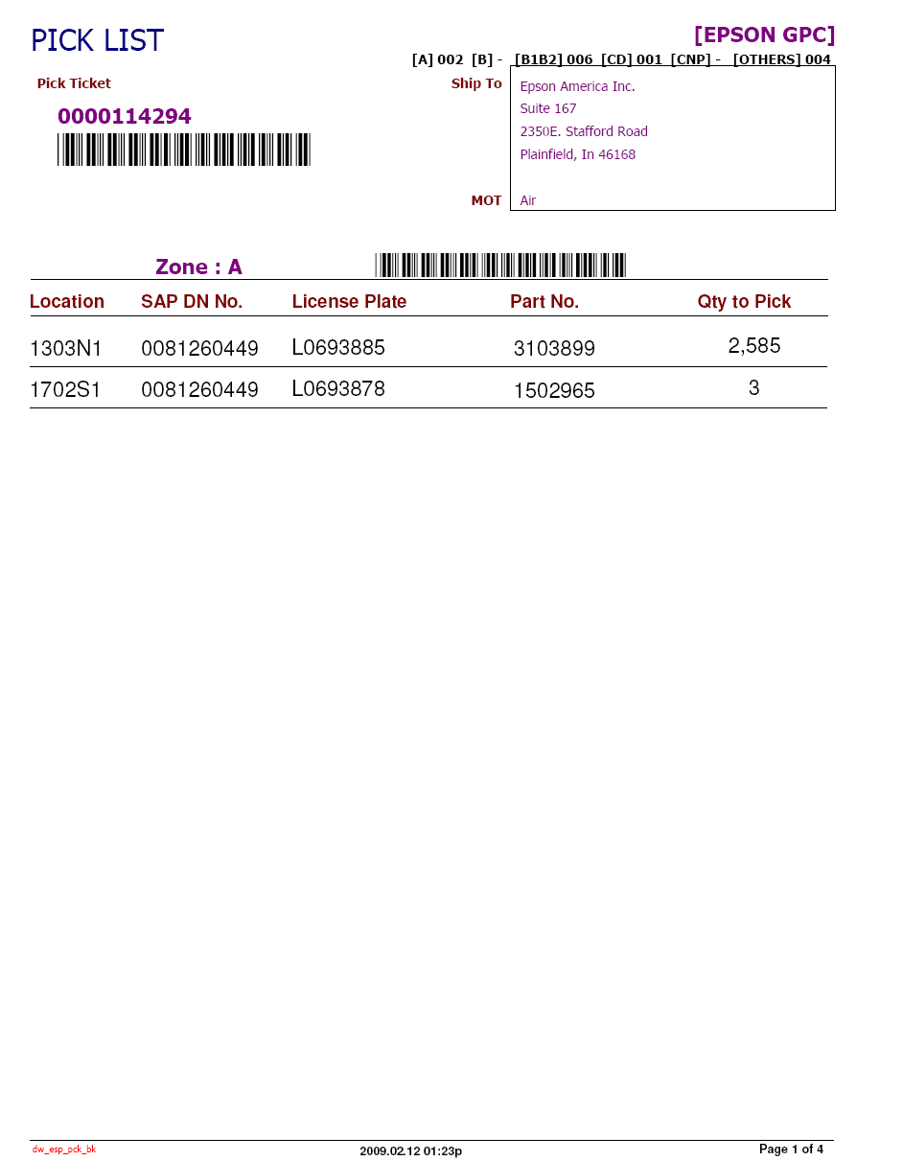
INDIVIDUAL PACKAGING

